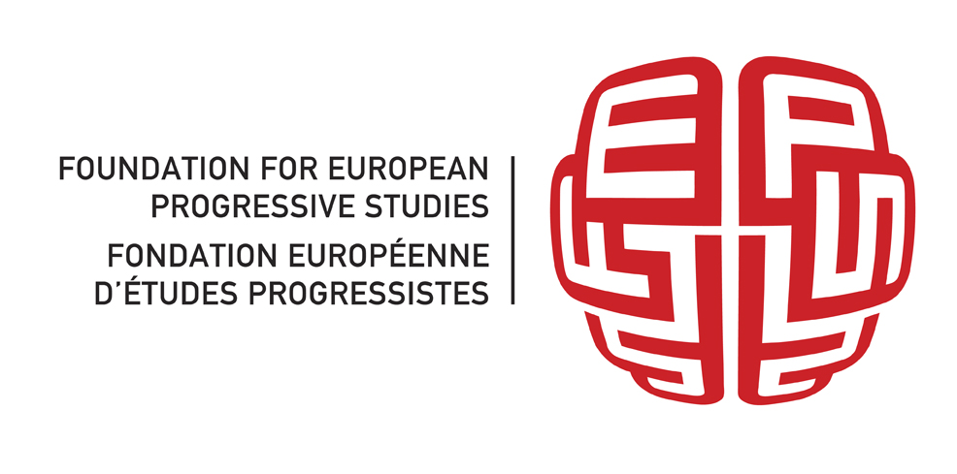
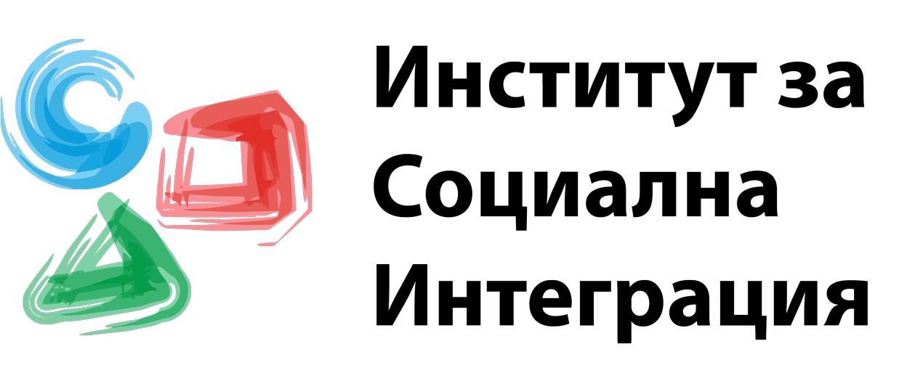

SUMMARY

Within the project "Early Parliamentary Elections 2014: Citizens Monitoring", the Institute for Social Integration /ISI/ carried out monitoring of the election campaign and its media coverage, as well as direct observation on the Election Day - through the registered civil observers in 25 constituencies of the country /out of 31 in total/. During the monitoring process, ISI partnered with a wide range of civil society organizations through the platform of the Public Council at the Central Election Commission and the Civil Board for Free and Fair Elections, constituted to the caretaker prime minister. They were provided the opportunity to receive updated information from the responsible institutions of the electoral process and the exchange of information between the organizations, registered as observers.
The monitoring of the European Parliament Elections 2014 showed that even after the entry into force of the new Electoral Code, the imperfections of the electoral process and the election campaign deepened. The new Electoral Code was adopted on 5 March 2014 and there were only two months available for its implementation. This made necessary to maintain monitoring on the establishment and introduction of the instruments for implementation of the regulations. An opportunity to do so was by tracking the activities of the Central Election Commission and by participating in its consultancy bodies.
The monitoring was done in three stages: analysis of the electoral legislation, civil monitoring of the Election Day and monitoring the messages during the election campaign. A team was formed for each stage.
A new element in the monitoring of the election campaign was the idea, developed by ISI, for an interactive Internet-platform for analysis of the election messages of major political forces. It presents graphically the main keywords in the statements of the candidates and allows for both quantitative and qualitative comparison of the positions of the parties on any important topic. With this endeavor, ISI aimed at helping the voter make a choice. Next, it allows for comparison and analysis of the statements of the main politicians’ and candidates’ messages, and the previously declared milestones in their election platforms and programs. It also allows for the comparison of the pre-stated intentions with the actions of the new rulers.
At the same time we were able to trace media behavior during the election process and its mediating role in passing the messages to the voters.
Based on the achievements of the monitoring in 2011, 2013 and 2014, ISI aimed at close monitoring of the election campaign and election process, including the Election Day. For third consecutive year, ISI was a registered observer at the Central Election Commission. Probable violations in the electoral process were given the necessary publicity and were reported to the responsible authorities and institutions. For this purpose, the already existing network of civil observers was used, as well as the newly trained civil observers in almost all constituencies of the country. We carried out training sessions of teams of observers’ coordinators. In their turn, they organized and carried out training workshops for their teams. To achieve better efficiency of the training process we used a video with a simulation game of the Election Day, which was performed during the monitoring of the elections in 2013. We also prepared presentation materials. On the Election Day, 05 October, the National Coordinator of ISI, together with a team of the organization, were taking in the alerts for violations from the coordinators in their respective areas of observation, summarized them and sent them to the responsible institutions and the media.

The results of the monitoring were presented at a final meeting and proposals for future actions were discussed.

